Exercise 00: Hello World

1. Make a new html file named *index.html* in Visual Studio Code.



1. Copy the basic HTML structure from [here](https://www.w3schools.com/html/) and paste it into your *index.html* file (or, use the following VS Code shortcut).



1. Modify the code with the words **Hello World** and save the file.
2. View the *index.html* file in the browser window. This can be done in a couple ways:
   1. Drag the *index.html* file from Finder and drop it into your web browser window.
   2. CTRL + Left Click (on Mac) or Right Click (on Windows) to open the *index.html* file in the browser  
        
      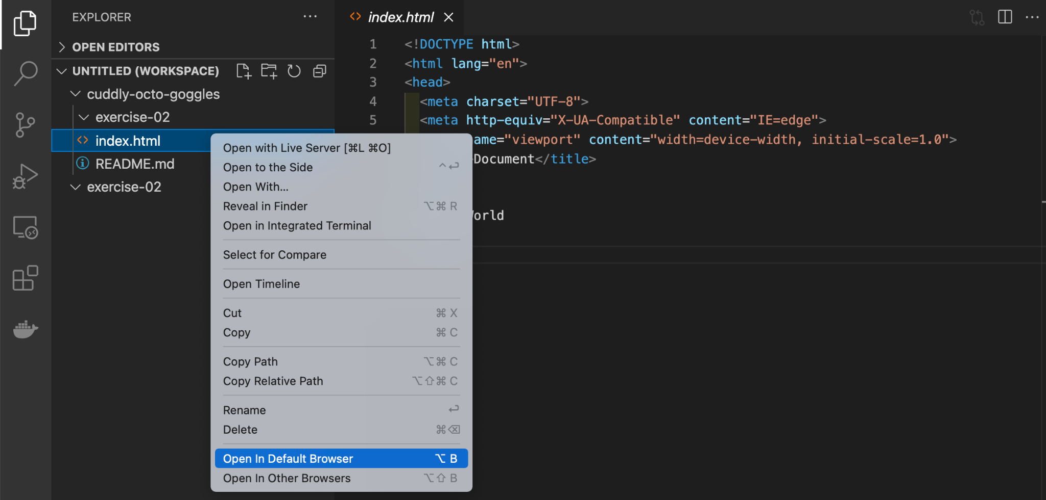
   3. Copy the full path of your file and paste it into the browser address bar. CTRL + Left Click (on Mac) or Right Click (on Windows) on the *index.html* file in the panel on the left and select “Copy Path”. Then, paste the path in the web browser.  
        
      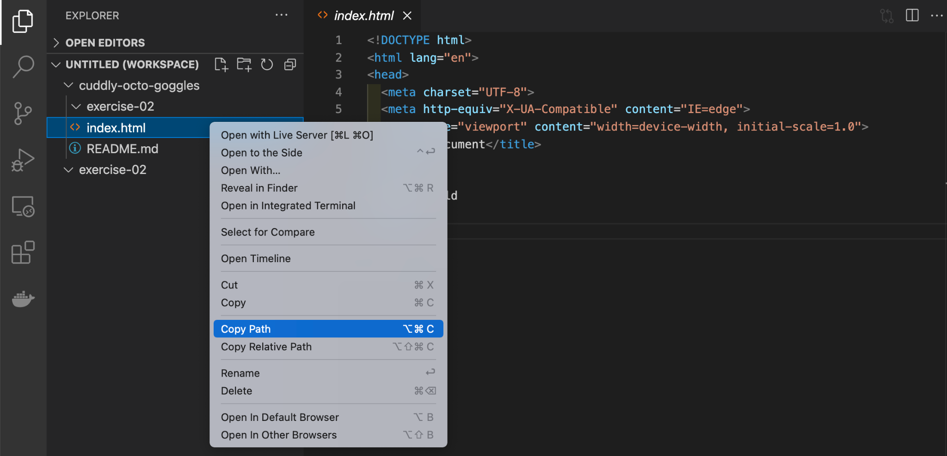

Note: refresh the browser window as you add new code to the file to see the new changes. Don’t forget to save!